Instructions for booking a room at Exe Moncloa Madrid with IESE special group rate
Direct link to booking webpage: https://www.eurostarshotels.com/exe-moncloa.html?referer_code=lb0gg00yx&utm_source=google&utm_medium=business&utm_campaign=lb0gg00yx&avail_code=lb0gg00yx
** This special IESE rate will be available until April 21.
- Once on the booking link, select check-in and check-out rates
- Where it says “promo code” insert this code: IESE2025, and click on “Search”.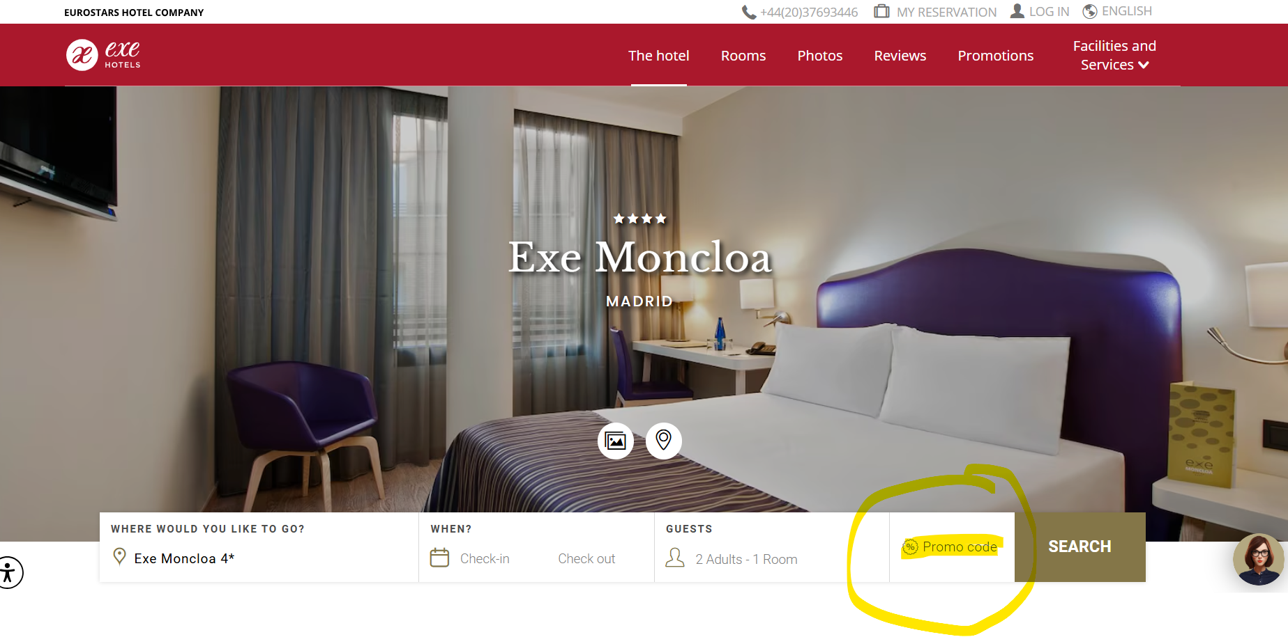
- Proceed with the rest of information requested by the hotel to complete the reservation. You will find the summary of the final price with the applied discount.

